http://www.thesolutionsjournal.com/node/556#

Feb 10, 2010
From a Failed-Growth Economy to a Steady-State Economy

By Herman Daly

Photograph by Jared Leeds
A steady-state economy is incompatible with continuous growth—either positive or negative growth. The goal of a steady state is to sustain a constant, sufficient stock of real wealth and people for a long time. A downward spiral of negative growth, a depression such as we are entering now, is a failed-growth economy, not a steady-state economy. Halting an accelerating downward spiral is necessary but is not the same thing as resuming continuous positive growth. The growth economy now fails in two ways: (1) positive growth becomes uneconomic in our full-world economy; (2) negative growth, resulting from the bursting of financial bubbles inflated beyond physical limits, though temporarily necessary, soon becomes self-destructive. That leaves a non-growing or steady-state economy as the only long-run alternative. The level of physical wealth that the biosphere can sustain in a steady state may well be below the present level. The fact that recent efforts at growth have resulted mainly in bubbles suggests that this is so. Nevertheless, current policies all aim for the full re-establishment of the growth economy. No one denies that our problems would be easier to solve if we were richer. The question is, does growth still make us richer, or is it now making us poorer?
I will spend a few more sentences cursing the darkness of growth but will then try to light ten little “policy candles” along the path to a steady state. Without a sufficiently dark background, the light of these candles is not visible in the false dawn projected by economists whose campaigning optimism never gives hope a chance to emerge from the shadows.
We have many problems (poverty, unemployment, environmental destruction, budget deficit, trade deficit, bailouts, bankruptcy, foreclosures, etc.), but apparently only one solution: economic growth, or as the pundits now like to say, “to grow the economy”— as if it were a potted plant.
But let us stop right there and ask two questions that all students should put to their economics professors.
First, there is a deep theorem in mathematics that says that when something grows, it gets bigger! How big can the economy get, Professor? How big is it now? How big should it be? And most pointedly, what makes economists think that growth (i.e., physical expansion of the economic subsystem into the finite, containing biosphere) is not already increasing environmental and social costs faster than production benefits, thereby becoming uneconomic growth, making us poorer, not richer? After all, real GDP, the measure of so-called economic growth, does not separate costs from benefits, but rather conflates them as “economic activity.” How would we know when growth became uneconomic? Remedial and defensive activity becomes ever greater as we grow from an “empty-world” to a “full-world” economy, characterized by congestion, interference, displacement, depletion, and pollution. The defensive expenditures induced by these negatives are all added to GDP, not subtracted. Be prepared, students, for some hand waving, throat clearing, and subject changing. But don’t be bluffed.
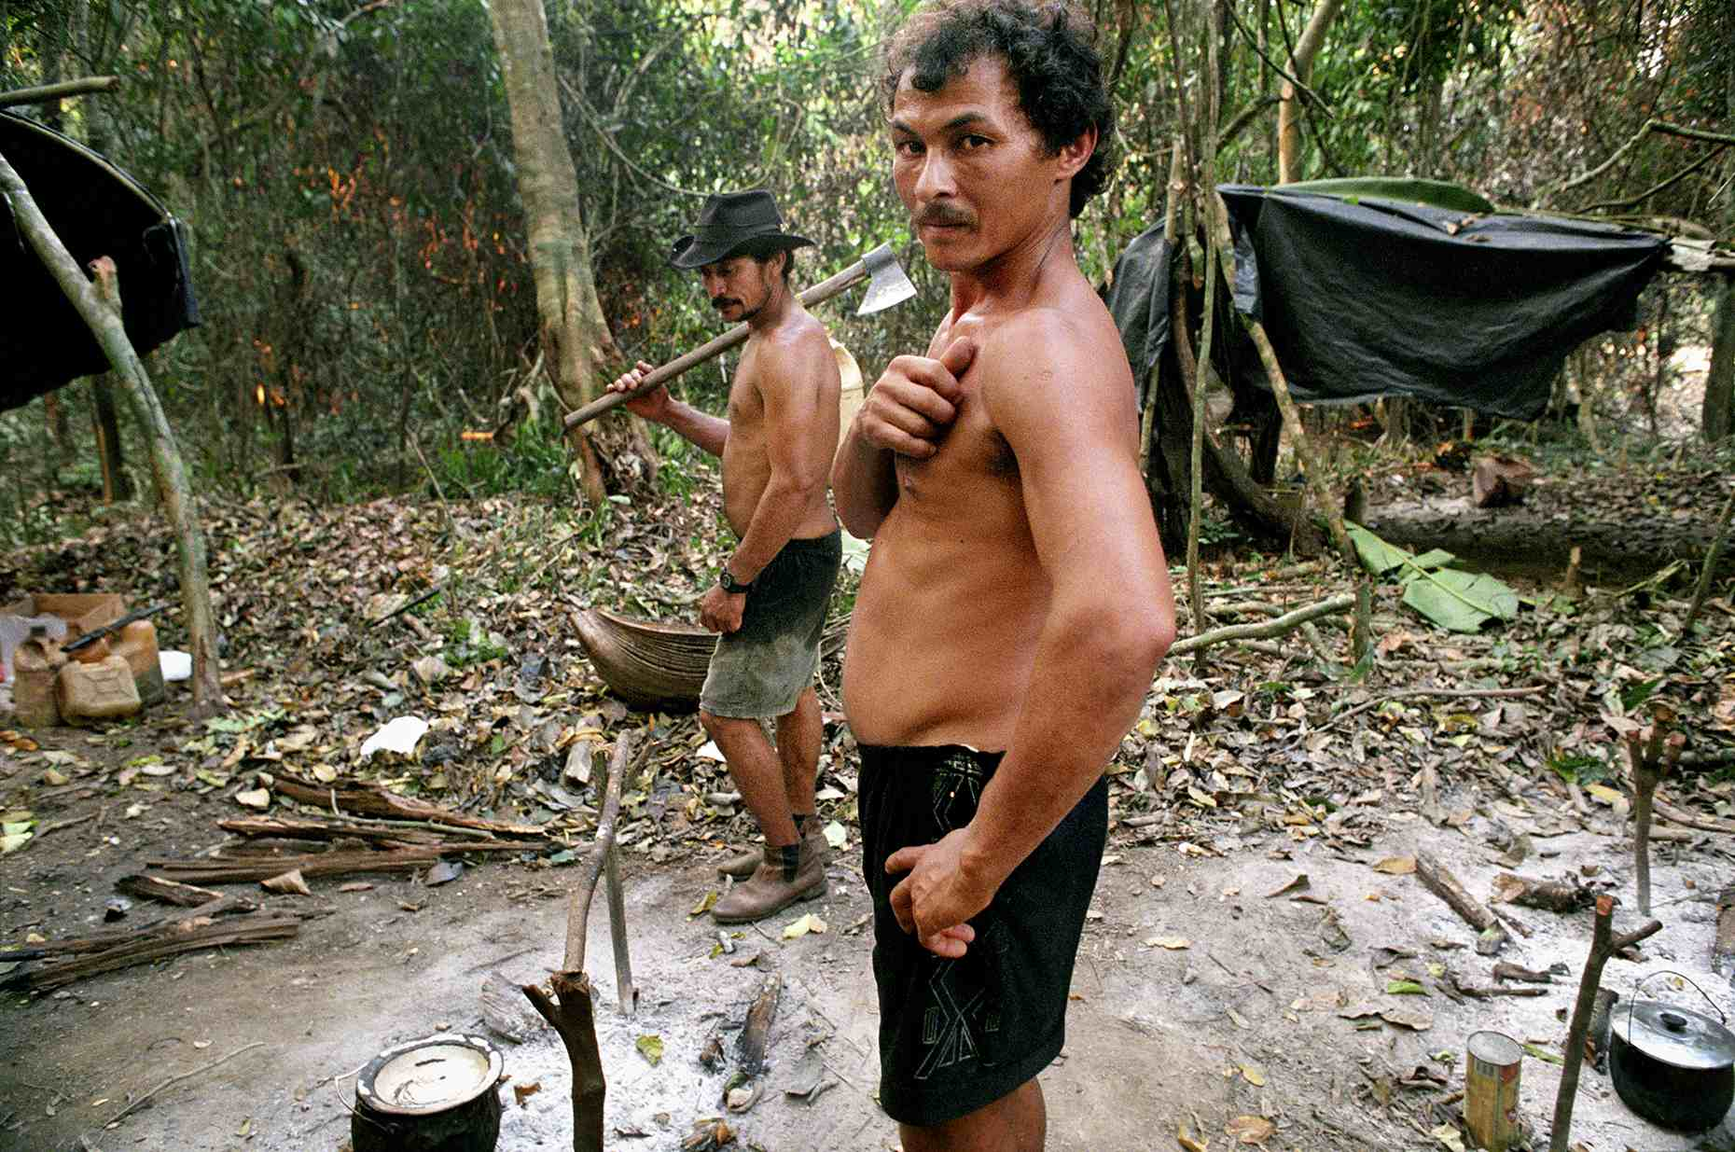
Photograph by Jared Leeds
Second question: do you then, Professor, see growth as a continuing process, desirable in itself, or as a temporary process required to reach a sufficient level of wealth that would thereafter be maintained more or less in a steady state? At least 99% of modern neoclassical economists hold the growth-forever view. We have to go back to John Stuart Mill and the earlier classical economists to find serious treatment of the idea of a non-growing economy, the Stationary State. What makes modern economists so sure that the classical economists were wrong? Just dropping History of Economic Thought from the curriculum is not a refutation!
Here are some reasons to think that the classical economists were right:
A long-run norm of continuous growth could make sense only if one of the following three conditions were true:
- the economy is not an open subsystem of a finite and non-growing biophysical system,
- the economy is growing in a non-physical dimension, or
- the laws of thermodynamics do not hold.
Let us consider each of these three logical alternatives. (If you can think of a fourth one, please let me know.)
- Some economists in fact think of nature as the set of extractive subsectors of the economy (forests, fisheries, mines, wells, pastures, and even agriculture). The economy, not the ecosystem or biosphere, is seen as the whole; nature is a collection of parts. If the economy is the whole, then it is not a part of any larger thing or system that might restrain its expansion. If some extractive natural subsector gets scarce, we will just substitute other sectors for it, and growth of the whole economy will continue, not into any restraining biospheric envelope, but into sidereal space presumably full of resource-bearing asteroids and friendly aliens eager to teach us how to grow forever into their territory. Sources and sinks are considered infinite.
- Some economists say that what is growing in economic growth is value, and value is not reducible to physical units. The latter is true, of course, but that does not mean that value is independent of physics! After all, value is price times quantity, and quantity is always basically physical. Even services are always the service of something or somebody for some time period, and people who render services have to eat. The value unit of GDP is not dollars, but a dollar’s worth. A dollar’s worth of gasoline is a physical amount, currently about half a gallon. The aggregation of the dollar’s worth amounts of many different physical commodities (GDP) does not abolish the physicality of the measure, even though the aggregate can no longer be expressed in physical units. True, $/q x q = $. But the fact that q cancels out mathematically does not mean that the aggregate measure, “dollar’s worth,” is just a pile of dollars. And it doesn’t help to speak instead of “value added” (by labor and capital) because we must ask, to what is the value added? The answer is natural resources, low-entropy matter/energy—not fairy dust or frog’s hair! Development (squeezing more welfare from the same throughput of resources) is a good thing. Growth (pushing more resources through a physically larger economy) is the problem. Limiting quantitative growth is the way to force qualitative development.
- If resources could be created out of nothing, and wastes could be annihilated into nothing, then we could have an ever-growing resource throughput by which to fuel the continuous growth of the economy. But the first law of thermodynamics says NO. Or if we could just recycle the same matter and energy through the economy faster and faster, we could keep growth going. The circular flow diagram seen in nearly all economics texts unfortunately comes very close to affirming this. But the second law of thermodynamics says NO.
So, if we can’t grow our way out of all problems, then maybe we should reconsider the logic and virtues of non-growth, the steady-state economy. And yet we see a refusal by neoclassical economists both to face common sense and to reconsider the ideas of the early classical economists—why?
I think the answer is distressingly simple. Without growth, the only way to cure poverty is through sharing. But redistribution is anathema. Without growth to push the hoped-for demographic transition, the only way to cure overpopulation is by population control. A second anathema. And without growth, the only way to increase funds to invest in environmental repair is by reducing current consumption. Anathema number three. Three anathemas and you’re out!
Without growth, how will we build up arsenals to protect democracy (and remaining petroleum reserves)? How will we go to Mars and Saturn and “conquer” space? Where can technical progress come from if not from unintended spin-offs from the military and from space research? Gnostic techno-fantasies of escaping Earth to outer space, partially turning off the sun to make more room for greenhouse gases in the atmosphere, and abolishing disease and death itself feed on the perpetual-growth myth of no limits. Digital-brained techies, who have never heard of the problem of evil, see heaven on earth just around the corner: “let’s build a smarter planet,” IBM modestly suggests. How about some smarter economists first?
Photograph by Jared Leeds
Without growth, we must find a different god to worship. The communist growth god has failed, but surely the capitalist growth god will not fail! Let’s jumpstart the GDP and the Dow Jones! Let’s build another tower of Babel with obfuscating technical terms like sub-prime mortgage, derivative, securitized investment vehicle, collateralized debt obligation, credit default swap, toxic assets, and insider slang like the “dead cat bounce.” (If you drop it from a high enough tower of Babel, even a dead cat will bounce enough to make some profit.)
Or, let us not do that. Let us ignore the anathemas and instead think about what policies would be required to move to a steady-state economy. They are a bit radical by present standards, but not nearly as unrealistic as any of the three alternatives given above for validating continuous growth.
Let us look briefly at ten specific policy proposals for moving to a steady-state economy, that is, an economy that maintains a constant metabolic flow of resources from depletion to pollution: a throughput that is within the assimilative and regenerative capacities of the ecosystem.
1. Cap-Auction-Trade Systems for Basic Resources. Caps limit biophysical scale by quotas on depletion or pollution, whichever is more limiting. Auctioning the quotas captures scarcity rents for equitable redistribution. Trade allows efficient allocation to highest uses. This policy has the advantage of transparency. There is a limit to the amount and rate of depletion and pollution that the economy can be allowed to impose on the ecosystem. Caps are quotas, limits to the throughput of basic resources, especially fossil fuels. The quota usually should be applied at the input end because depletion is more spatially concentrated than pollution and hence easier to monitor. Also, the higher price of basic resources will induce their more economical use at each upstream stage of production. It may be that the effective limit in use of a resource comes from the pollution it causes rather than from depletion—no matter, we indirectly limit pollution by restricting depletion of the resource that ultimately is converted into wastes. Limiting barrels, tons, and cubic feet of carbon fuels extracted per time period will limit tons of CO2 emitted per time period. This scale limit serves the goal of biophysical sustainability. Ownership of the quotas is initially public—the government auctions them to individuals and firms. The revenues go to the treasury and are used to replace regressive taxes, such as the payroll tax, and to reduce income tax on the lowest incomes. Once purchased at auction, the quotas can be freely bought and sold by third parties, just as can the resources whose rate of depletion they limit. The trading allows efficient allocation, the auction serves just distribution, and the cap serves the goal of sustainable scale. The same logic can be applied to limiting the off-take from fisheries and forests. With renewables, the quota should be set to approximate sustainable yield. For non-renewables, sustainable rates of absorption of resulting pollution or the rate of development of renewable substitutes may provide a criterion.
2. Ecological Tax Reform. Shift the tax base from value-added (labor and capital) to “that to which value is added,” namely the entropic throughput of resources extracted from nature (depletion) and returned to nature (pollution). This internalizes external costs and raises revenue more equitably. It prices the scarce, but previously un-priced, contribution of nature. Value-added is something we want to encourage, so stop taxing it. Depletion and pollution are things we want to discourage, so tax them. Ecological tax reform can be an alternative or a supplement to cap-auction-trade systems. Value-added is simultaneously created and distributed in the very process of production. Therefore, economists argue that there is no “pie” to be independently distributed according to ethical principles. As Kenneth Boulding put it, instead of a pie, there are only a lot of little “tarts” consisting of the value added by different people or different countries that are blindly aggregated by statisticians into an abstract “pie” that doesn’t really exist as an undivided totality. To redistribute this imaginary pie, one should appeal to the generosity of those who baked larger tarts to share with those who baked smaller tarts, not to some invidious notion of equal participation in a fictitious common inheritance.
I have considerable sympathy with this view, as far as it goes. But it leaves out something very important.
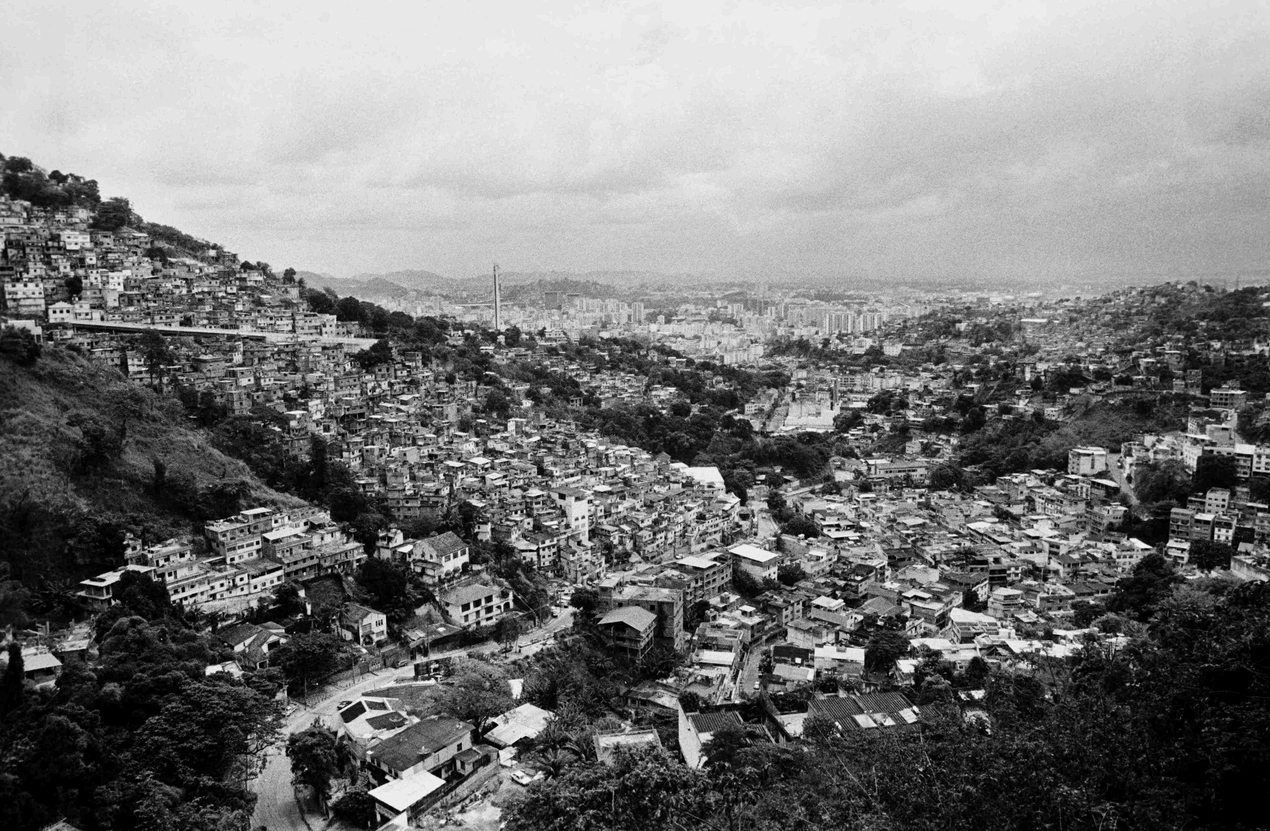
Photograph by Jared Leeds
In our one-eyed focus on value-added, we economists have neglected “that to which value is added,” namely the flow of resources and services from nature. “Value-added” by labor and capital has to be added to something, and the quality and quantity of that something are important. Now, there is a real and important sense in which the original contribution of nature is indeed a “pie,” a pre-existing, undivided totality that we all share as an inheritance. It is not an aggregation of little tarts that we each baked ourselves. Rather it is the seed, soil, sunlight, and rain (not to mention the gene pools and suitable climate) from which the wheat and apples, converted into tarts by our labor and capital, grew. The claim for equal access to nature’s gifts is not the invidious coveting of what our neighbor accumulated through her own labor and abstinence. The focus of our demands for income to redistribute to the poor, therefore, should be on the value of nature’s contribution, the original value of that to which further value is added by labor and capital.
3. Limit the Range of Inequality in Income Distribution. Without aggregate growth, poverty reduction requires redistribution. Complete equality is unfair; unlimited inequality is unfair. So we need to seek fair limits to the range of inequality: a minimum income and a maximum income. The civil service, the military, and the university manage with a range of inequality that stays within a factor of 15 or 20. Corporate America has a range of 500 or more. Many industrial nations are below 25. Could we not limit the range to, say, 100, and see how it works? People who have reached the limit could either work for nothing at the margin if they enjoy their work or devote their extra time to hobbies or public service. The demand left unmet by those at the top will be filled by those who are below the maximum. A sense of community, necessary for democracy, is hard to maintain across the vast income differences in the U.S. When rich and poor are separated by a factor of 500, they become almost different species. The main justification for such differences has been that they stimulate growth, which will one day make everyone rich. This may have had superficial plausibility in an empty world, but in our full world, it is a fairy tale. I have advocated for a maximum income as well as a minimum income for a long time. The idea has been very unpopular, but thanks to the banksters and their bonuses, it is now becoming more popular.
4. Free Up the Length of the Working Day, Week, and Year. We need to allow greater options for part-time or personal work. Full-time external employment for all is hard to provide without growth. Other industrial countries have much longer vacations and maternity leaves than the U.S. For the classical economists, the length of the working day was a key variable by which the worker (self-employed yeoman or artisan) balanced the marginal disutility of labor with the marginal utility of income and of leisure so as to maximize enjoyment of life. Under industrialism, the length of the working day became a parameter rather than a variable (and for Karl Marx was the key determinant of the rate of exploitation). We need to make it more of a variable, subject to choice by the worker. Milton Friedman wanted “Freedom to Choose”— OK, here is an important choice most of us are not allowed to make! And we should stop biasing the labor–leisure choice by using advertisements to stimulate more consumption and more labor to pay for it. Advertising should no longer be treated as a tax-deductible, ordinary expense of production.
5. Re-Regulate International Commerce. It is time for us to move away from free trade and free capital mobility and globalization. We should adopt compensating tariffs to protect efficient national policies of cost internalization from standards-lowering competition by foreign firms that are not required to count their full environmental and social costs. This “new protectionism” is very different from the “old protectionism” that was designed to protect a truly inefficient domestic firm from a more efficient foreign firm. We cannot integrate with the global economy and at the same time have higher wages, environmental standards, and social safety nets than the rest of the world. Trade and capital mobility must be balanced and fair, not deregulated or “free.” Tariffs are also a good source of public revenue. This will run afoul of the WTO, so….
6. Downgrade the IMF/WB/WTO to something like Keynes’ original plan for a multilateral, payments-clearing union, charging penalty rates on surplus as well as deficit balances. Seek balance on current accounts, and thereby avoid large foreign debts and capital account transfers. For example, under Keynes’ plan, the U.S. would pay a penalty charge to the clearing union for its large deficit with the rest of the world, and China would also pay a similar penalty for its surplus. Both sides of the imbalance would be pressured to balance their current accounts by financial penalties and, if need be, by exchange rate adjustments relative to the clearing account unit, called “the bancor” by Keynes. The bancor would serve as world reserve currency, a privilege that should not be enjoyed by any national currency. The bancor would be like gold under the gold standard, only you would not have to dig it out of the ground. The International Monetary Fund (IMF) preaches free trade based on comparative advantage and has done so for a long time. More recently, the IMF, World Bank (WB), and World Trade Organization (WTO) have started preaching the gospel of globalization, which, in addition to free trade, means free capital mobility internationally. The classical comparative advantage argument, however, explicitly assumes international capital immobility! When confronted with this contradiction, the IMF waves its hands, suggests that you might be a xenophobe, and changes the subject. The IMF, WB, and WTO contradict themselves in service of the interests of transnational corporations. International capital mobility, coupled with free trade, allows corporations to escape from national regulation in the public interest, playing one nation against another. Since there is no global government, they are, in effect, uncontrolled. The nearest thing we have to a global government, IMF/World Bank/WTO, has shown no interest in regulating transnational capital for the common good.
7. Move Away from Fractional Reserve Banking Toward a System of 100% Reserve Requirements. This would put control of the money supply and seigniorage in the hands of government rather than private banks, which would no longer be able to create money out of nothing and lend it at interest. All quasi-bank financial institutions should be brought under this rule, regulated as commercial banks subject to 100% reserve requirements. Banks would earn their profit by financial intermediation only, lending savers’ money for them (charging a loan rate higher than the rate paid to savings account depositors) and charging for checking, safekeeping, and other services. With 100% reserves, every dollar loaned to a borrower would be a dollar previously saved by a depositor, re-establishing the classical balance between abstinence and investment. The government can pay its expenses by issuing more non-interest-bearing fiat money to make up for the eliminated bank-created, interest-bearing money. However, it can only do this up to a strict limit imposed by inflation. If the government issues more money than the public wants to hold, the public will trade it for goods, driving the price level up. As soon as the price index begins to rise, the government must print less and tax more. Thus a policy of maintaining a constant price index would govern the internal value of the dollar. The external value of the dollar could be left to freely fluctuating exchange rates (or preferably to the rate against the bancor in Keynes’ clearing union).
Photograph by Jared Leeds
8. Stop Treating the Scarce As If It Were Non-Scarce, but Also Stop Treating the Non-Scarce As If It Were Scarce. We should enclose the remaining commons of rival natural capital (e.g. atmosphere, electromagnetic spectrum, public lands) in public trusts, and price them by a cap-auction-trade system, or by taxes, while freeing from private enclosure and prices the non-rival commonwealth of knowledge and information. Knowledge, unlike throughput, is not divided in the sharing, but multiplied. Once knowledge exists, the opportunity cost of sharing it is zero, and its allocative price should be zero. International development aid should more and more take the form of freely and actively shared knowledge, along with small grants, and less and less the form of large, interest-bearing loans. Sharing knowledge costs little, does not create un-repayable debts, and increases the productivity of the truly rival and scarce factors of production. Existing knowledge is the most important input to the production of new knowledge, and keeping it artificially scarce and expensive is perverse. Patent monopolies (also known as “intellectual property rights”) should be given for fewer “inventions” and for fewer years. Costs of production of new knowledge should, more and more, be publicly financed and then the knowledge freely shared.
9. Stabilize Population. We should be working toward a balance in which births plus in-migrants equals deaths plus out-migrants. This is controversial and difficult, but, as a start, contraception should be made available for voluntary use everywhere. And while each nation can debate whether it should accept many or few immigrants, and who should get priority, such a debate is rendered moot if immigration laws are not enforced. We should support voluntary family planning and enforcement of reasonable immigration laws, democratically enacted. A lot of the pro-natalist and open-borders rhetoric claims to be motivated by generosity, but it is “generosity” at the expense of the U.S. working class—a cheap labor policy. Progressives have been slow to understand this. The environmental movement began with a focus on population but has frequently given in to political correctness.
10. Reform National Accounts. GDP should be separated into a cost account and a benefits account. We could then compare them at the margin and stop throughput growth when marginal costs equal marginal benefits. In addition to this objective approach, we should recognize the importance of the subjective studies that show that, beyond a threshold, further GDP growth does not increase self-evaluated happiness. Beyond a level already reached in many countries, GDP growth delivers no more happiness but continues to generate depletion and pollution. At a minimum, we must not just assume that GDP growth is “economic growth,” but we must prove it. And we can start by trying to refute the mountain of contrary evidence.
While these policies will appear radical to many, it is worth remembering that they are amenable to gradual application. 100% reserves can be approached gradually, the range of distribution can be restricted gradually, caps can be adjusted gradually, and so on. Also, these measures are based on the conservative institutions of private property and decentralized market allocation. They simply recognize that private property loses its legitimacy if too unequally distributed and that markets lose their legitimacy if prices do not tell the whole truth about opportunity costs. In addition, the macro-economy becomes an absurdity if its scale is structurally required to grow beyond the biophysical limits of the Earth. And well before reaching that radical physical limit, we are encountering the conservative economic limit in which extra costs of growth become greater than the extra benefits, ushering in the era of uneconomic growth, so far unrecognized.

